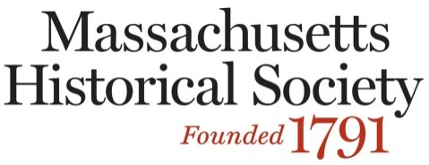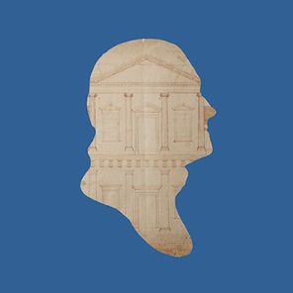
Teaching Thomas Jefferson, April 20, 2016
Name:

School or District & Grade level Taught (if applicable):

Home Address:

City:

State:

Zip:

Email (Required):

Registration fee: $25 (to cover lunch and materials)

Payment:

___Check is enclosed (payable to MHS)

___Visa ___MasterCard ___American Express ___Discover

Card Number:

Expiration Date:

Signature:

Name on Card:

Please print this form, fill it out, and return it with your payment to:

Kathleen Barker
Massachusetts Historical Society
1154 Boylston Street
Boston, MA 02215
education@masshist.org
617-646-0557

